**Create an EBS Snapshot**

**Step 3.8.1:** Creating an EBS snapshot

* Select *Volume* in EC2 dashboard
* Click on *Action* -> *Create Snapshot*

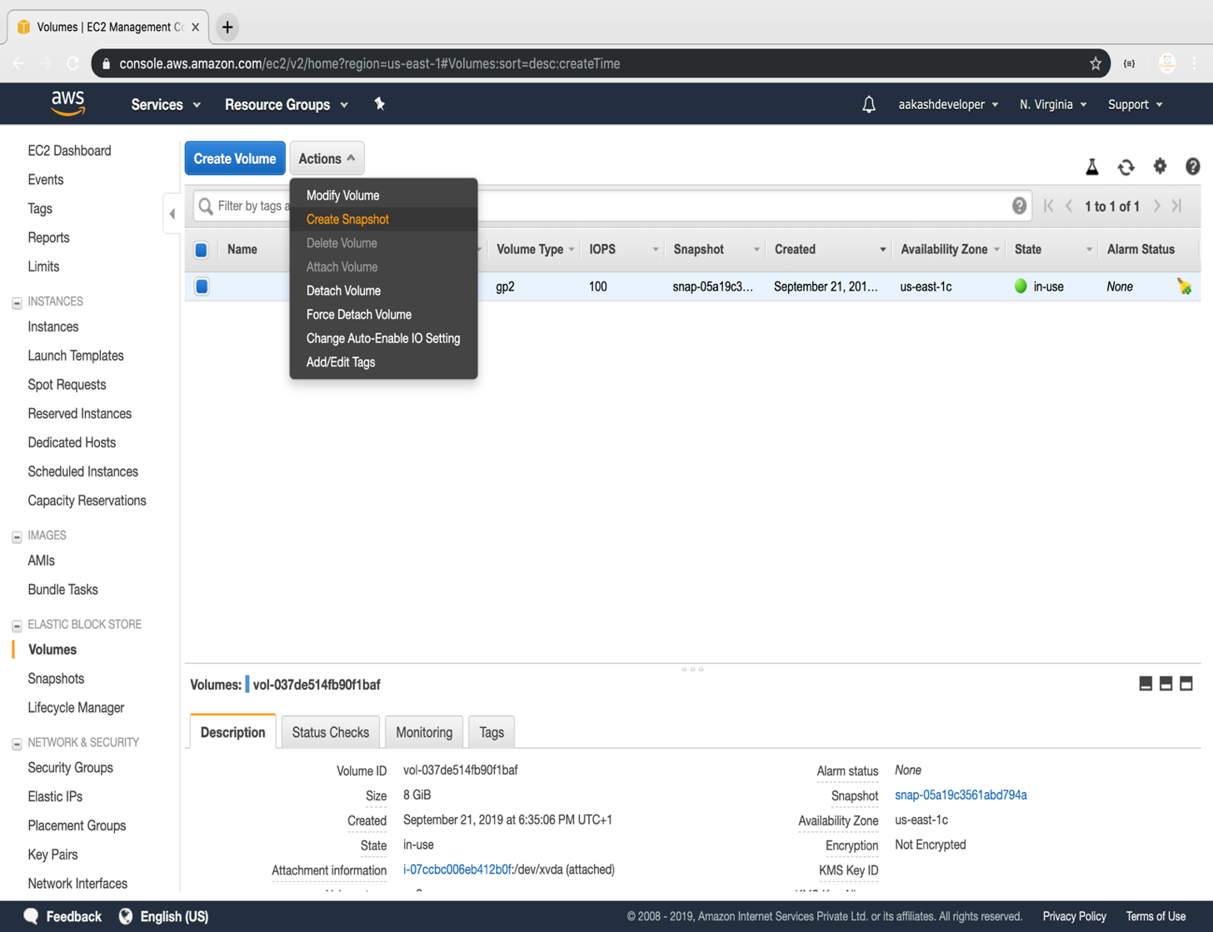

* Add snapshot name, key, and value

